- Reel Pops show up on forms pages on godam video in editor (noticed on Ninja & Met form)
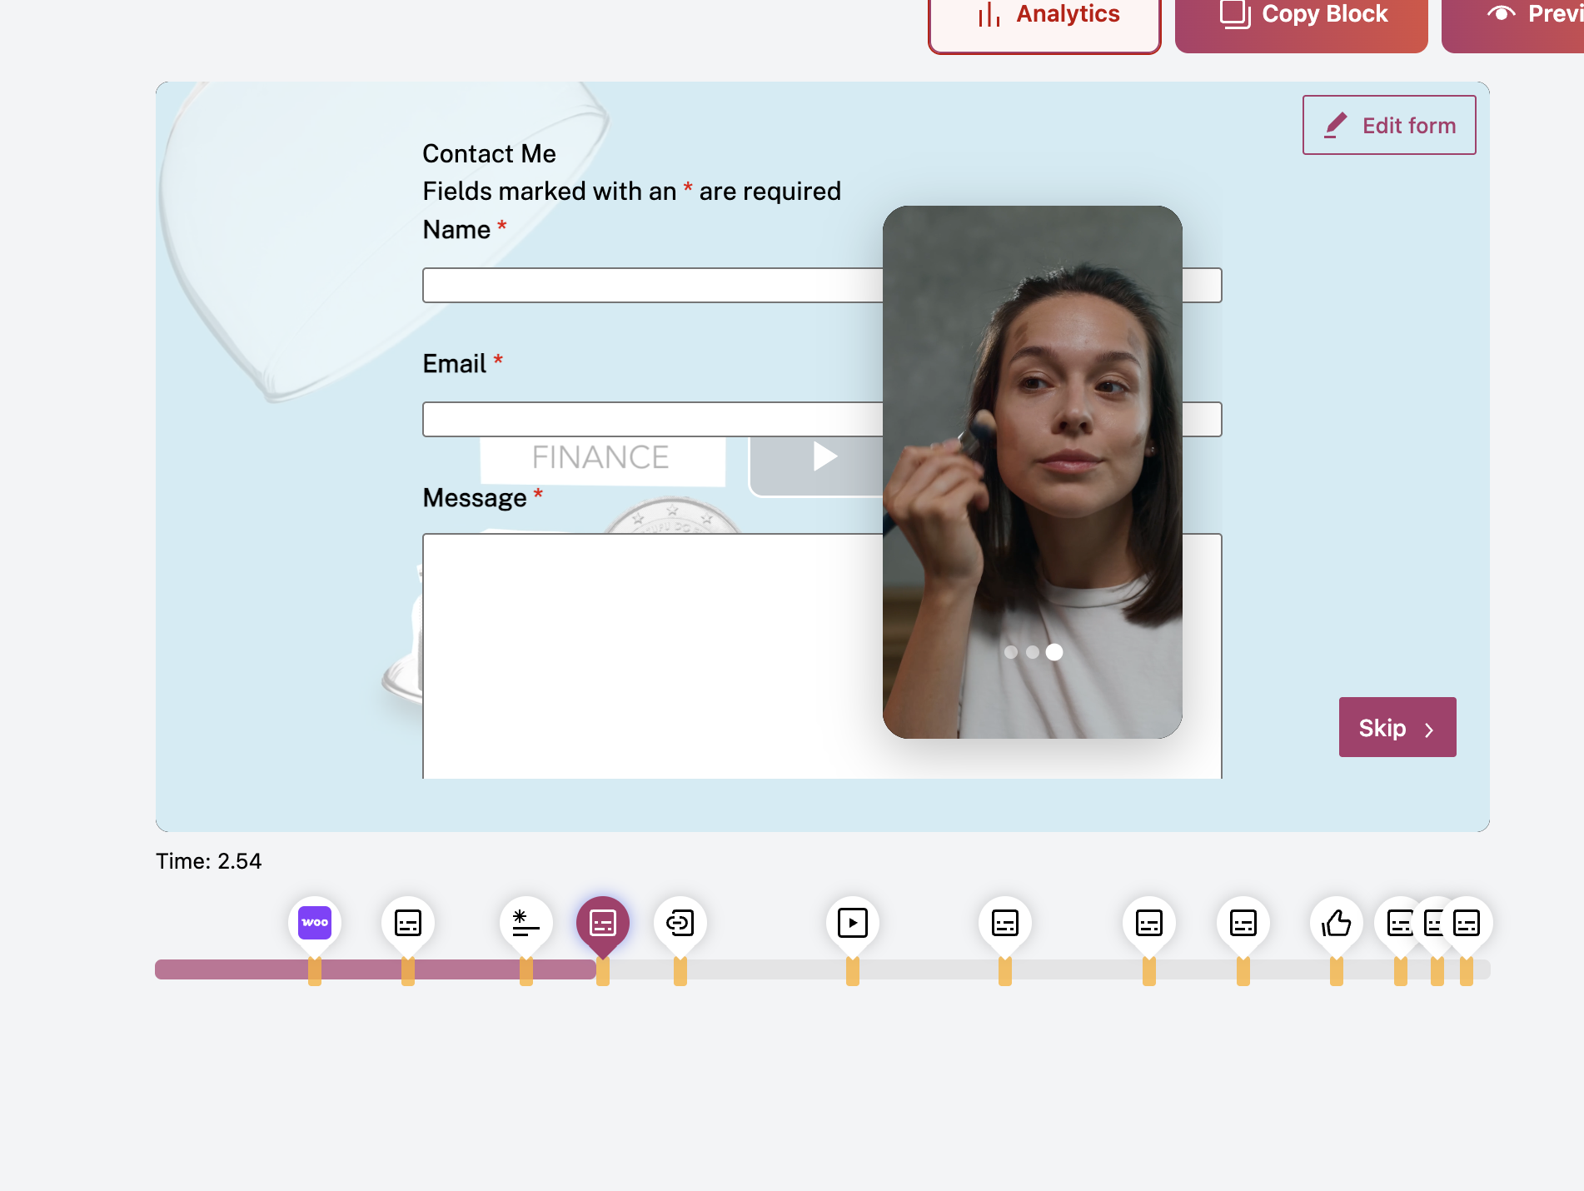
- Reel pops show inside the godam gallery on frontend
Reason: the modal has home class in its class which is treating it as homepage.
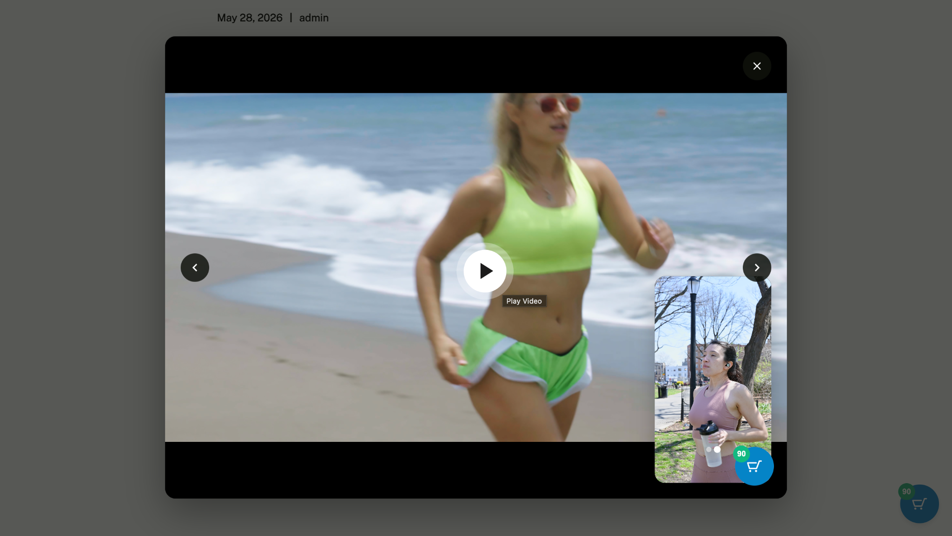
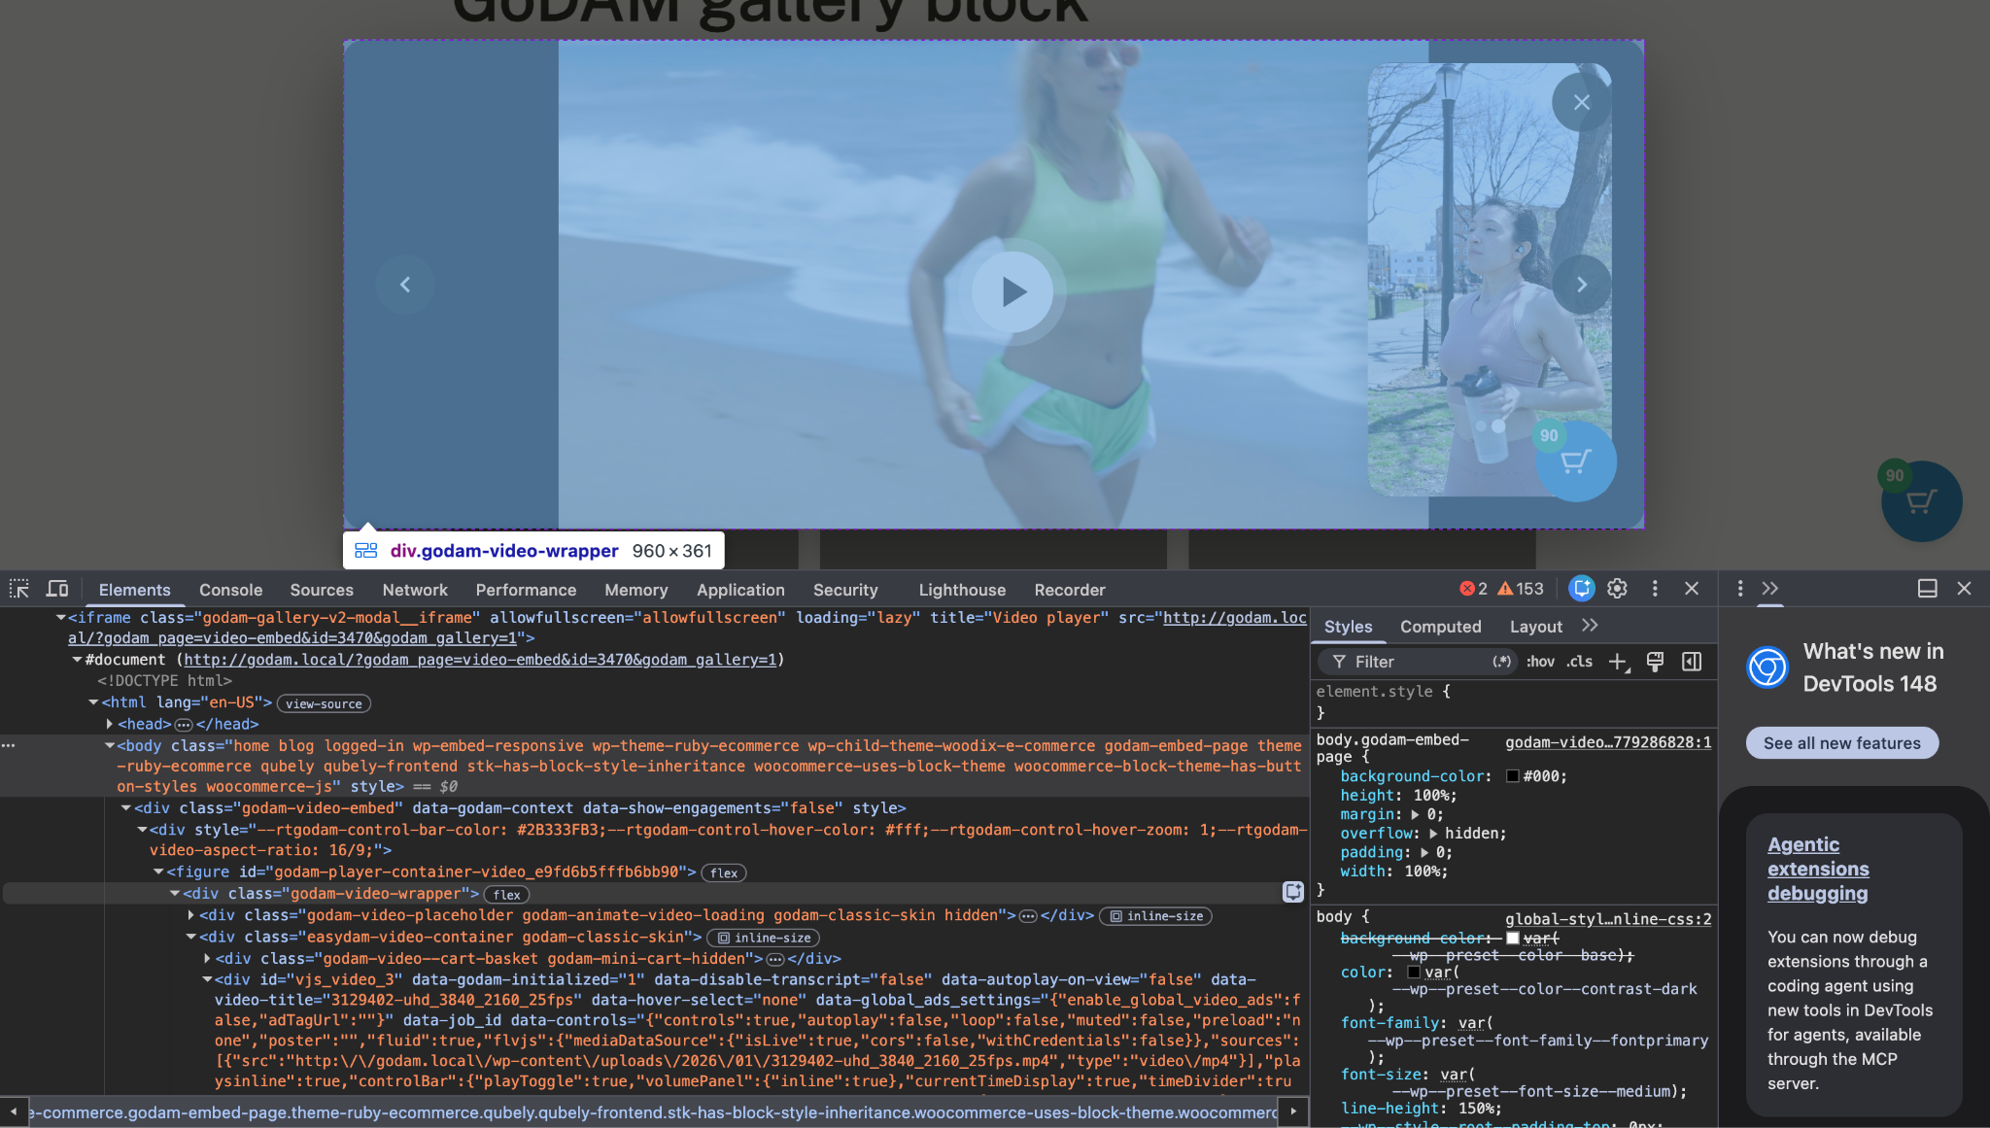

- Seeing reel pops on elementor backend
